Software Quality Assurance Methodology

CARMAN OKON
Version 1.0
Revision Date April 24, 2016
Revision Record

Version No | Author | Update Date | Reasons for Change
1.0 | Carman Okon | July 24/2015 | Original
Table of Contents
1.0 Overview 5
1.1 Purpose and Scope 5
1.2 Definitions 5
1.2.1 Types of Testing 7
2.0 Quality Goals 9
3.0 V Model for SQA Activities 9
4.0 Test Approach 10
4.1 Methodology 10
4.2 Source Environment 10
4.3 Overall Testing Approach 11
4.4 SQA Activities per phase 11
4.5 Test Plan 11
4.6 Test Case Standardization 12
4.7 Test Traceability Matrix 12
4.8 Testing Workflow 12
4.9 Unit and Development Testing 12
4.10 System and Integration Testing 12
4.11 Regression Testing 13
4.11.1 Test Case Priority 13
4.12 Metrics 13
4.12.1 Test Case Metrics 13
4.12.2 Test Execution Metric 14
4.12.3 Defect Growth 15
4.13 Entry and Exit Criteria 15
4.13.1 SQA Test Entry Criteria: 15
4.13.2 SQA Test Exit Criteria: 15
5.0 Roles and Responsibilities and Software Tools 16
5.1 SQA Roles and Responsibilities 16
5.2 Software 17
6.0 Defect Management 18
6.1 Required and Option fields for Defect Tracking 19
6.2 Project Defect meeting 19
6.3 Product Defect meeting 19
6.4 Defect Priority Classifications 20
6.5 Defect Severity Classifications 21
7.0 Test Tool Integration 22
7.1 Defect Management 22
7.2 Test Management 22
7.3 Test Case Tracking 23
7.3.1 ALM/Quality Center Project 23
7.3.2 Quality Center Releases and Cycles 24
7.3.3 Quality Center Test Plan and Test Lab 25
7.4 Automated Regression 26
7.5 Automated Performance 26
8.0 Risks and Issues 27
9.0 References 27
9.1 Industry Standards and Guidances 27
9.1.1 IEEE Std 829-2008, Standard for Software Test Documentation 27

Table of Figures
Figure 1 V Model 9
Figure 2 SQA Activities 10
Figure 3 Test Case Growth Charts 14
Figure 4 Defect Growth Chart 15
Figure 5 Defect Workflow 18
Figure 8 Project Set up 23
Figure 9 Quality Center Releases 24
Figure 10 Quality Center Test Plan Hierarchy 25
Figure 11 Quality Center Test Case Tabs 26

Overview

Purpose and Scope
The purpose of this document is to communicate the high-level test strategy and describe plans, procedures, and tasks required to accomplish required testing for all assigned products.
It will:
- Identify the software quality goals and define the metrics to be generated to prove the success of the project.
- Identify artifacts that will be produced and testing methodology used to validate these artifacts.
- Identify the team structure needed for the testing efforts on projects
- Specify the testing methodology

Definitions
Automated Testing:

- Testing employing software tools which execute tests without manual intervention. Can be applied in GUI, Performance, API, etc. testing.
- The use of software to control the execution of tests, the comparison of actual outcomes to predicted outcomes, the setting up of test preconditions, and other test control and test reporting functions.

Defect: Nonconformance to requirements or functional / program specification

Integration Testing: Testing of combined parts of an application to determine if they function together correctly. Usually performed after system testing has been completed. This type of testing is especially relevant to client/server and distributed systems.

Metric: A standard of measurement. Software metrics are the statistics describing the structure or content of a program. A metric should be a real objective measurement of something such as number of bugs per lines of code.

Performance Testing: Testing conducted to evaluate the compliance of a system or component with specified performance requirements. Often this is performed using an automated test tool to simulate large number of users. Also know as "Load Testing".

Quality Assurance: All those planned or systematic actions necessary to provide adequate confidence that a product or service is of the type and quality needed and expected by the customer.

Smoke Testing: A quick-and-dirty test confirms that the major functions of a piece of software work.

Test Case:

- Test Case is a commonly used term for a specific test. This is usually the smallest unit of testing. A Test Case will consist of information such as requirements testing, test steps, verification steps, prerequisites, outputs, test environment, etc.
- A set of inputs, execution preconditions, and expected outcomes developed for a particular objective, such as to exercise a particular program path or to verify compliance with a specific requirement.

Test Plan: A document describing the scope, approach, resources, and schedule of intended testing activities. It identifies test items, the features to be tested, the testing tasks, who will do each task, and any risks requiring contingency planning. Ref IEEE Std 829.

Test Procedure: A document providing detailed instructions for the execution of one or more test cases.

Test Scenario: Definition of a set of test cases or test scripts and the sequence in which they are to be executed.

Test Script: Commonly used to refer to the instructions for a particular test that will be carried out by an automated test tool.

Test Specification: A document specifying the test approach for a software feature or combination or features and the inputs, predicted results and execution conditions for the associated tests.

Test Suite: A collection of tests used to validate the behavior of a product. The scope of a Test Suite varies from organization to organization. There may be several Test Suites for a particular product for example. In most cases however, a Test Suite is a high level concept, grouping together hundreds or thousands of tests related by what they are intended to test.

Traceability Matrix: A document showing the relationship between Test Requirements and Test Cases. Generated from Quality Center.

Types of Testing
To ensure the software delivered is of high quality, the project team conducts the following types of testing. These descriptions are intended to provide an overview of quality assurance procedures used for internal verification before delivery. The types of testing depend on the level and type of project.

Test Type | Responsibility | Description
Black box Testing | SQA | Testing based on an analysis of the specification of a piece of software without reference to its internal workings. The goal is to test how well the component conforms to the published requirements for the component.
White box Testing | Software Engineering | Testing based on an analysis of internal workings and structure of a piece of software. Includes techniques such as Branch Testing and Path Testing. Also known as Structural Testing and Glass Box Testing. Contrast with Black Box Testing.
Unit Testing | Software Engineering | Unit Testing (also referred to as “Low Level Testing,” “Component Testing”) is the structured exercise of a component or small, discretely defined portion of code using a written plan or defined methodology that verifies that the component or small portion of the software behaves as expected based upon the specification. White box testing will be used for this type of test.
Dev Testing | Software Engineering | Dev Testing verifies combined parts of an application to ensure they function together properly. The parts can be code modules, individual applications, client /server applications on a network, etc. As more components are completed and added, the application is continually tested to ensure it functions as a whole. White box testing will be used for this type of test.
Smoke Testing/Critical Path Testing | SQA | Upon receiving a build for testing, SQA will initially conduct a Smoke Test/Critical Path A quick-and-dirty test confirms the major functions of a piece of software work. This will help to ensure that defects related to critical functionality are found early and thus allow the Software Engineering Team adequate time to enact repairs. It will also validate that the build is stable enough for further testing. Black box testing will be used for this type of test.
System Testing | SQA | Testing the features and operational behavior of a product to ensure they correspond to its specifications.  Testing that ignores the internal mechanism of a system or component and focuses solely on the outputs generated in response to selected inputs and execution conditions. See also Black Box Testing.
Regression Testing | SQA | Regression testing is done when changes are made to the code that is already tested or new releases that are made that may affect the product already released. Automation will be used when feasible for this type of testing. Black box testing will be used for this type of test.
Risk Based Testing | SQA | Risk Based Testing is a type of software testing that prioritizes the features and functions to be tested based on priority/importance and likelihood or impact of failure.
Performance Profiling /Load Testing | SQA | Performance profiling is a performance test in which response times, transaction rates, and other time-sensitive requirements are measured and evaluated. The goal of Performance Profiling is to verify performance requirements have been achieved. Performance profiling is implemented and executed to profile and tune a target-of-test's performance behaviors as a function of conditions such as workload or hardware configurations. A tool such as Compuware’s SQA Load will be used for this type of testing.
Integration Testing | SQA | Testing performed to expose defects in the interfaces and in the interactions between integrated components or systems.

Quality Goals
The goal of SQA is to ensure that all applications meet all (functional and non-functional) requirements as defined by the reviewed and signed off requirement documents and established procedures.

The primary goals of the SQA Team are:
- Ensure that the software satisfies documented requirements (functional and non-functional).
- Ensure the application works according to the functional requirements or use cases.
- Ensure regression tests are automated where feasible.
- Ensure that subsequent software release iterations do not have a negative impact on the current functioning system.
- Ensure the application meets the customer’s performance, reliability, and stability objectives under simulated production load.

V Model for SQA Activities
The following model (Figure 1 V Model) and (Figure 2 SQA Activities) will be used for cross reference of SQA activities/artifacts in the software development life cycle to the development artifacts.
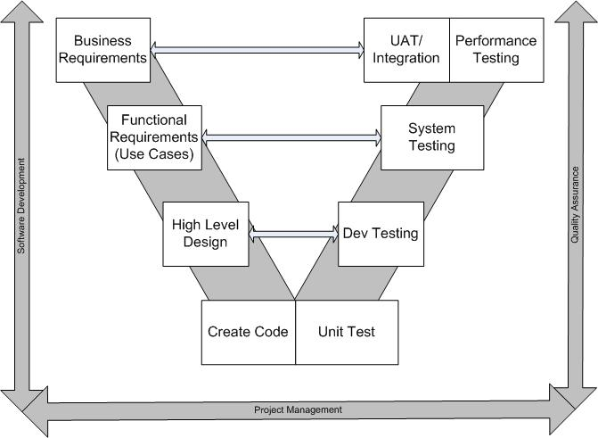
Figure 1 V Model

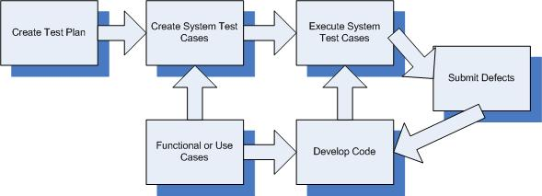
Figure 2 SQA Activities

Test Approach

Methodology
The testing methodology that will be engaged ensures that testing will be started as soon as possible allowing for quick response of issues found during the each test cycle while engaging the SQA team early on in the project. Testing will be completed in several phases starting with unit testing and ending with performance and Beta testing. Unit testing shall start when code is checked into the repository. Dev Testing starts when the code passes unit testing, review, and is ready to be integrated with the code base. Once all entrance criteria have been met for the release to be tested, Official system testing will be started.

SQA activities should start on or before requirements review phase (Elaboration). SQA team should be fully engaged once requirements have been delivered for review so that they can be verified to be testable and traceable. A test plan shall be created and finalized shortly after review cycle begins of the requirements.

System testing will be completed by the SQA team using manual methods. Automated testing will be used where feasible for regression testing using approved tools. Most Regression test cases will be automated by SQA team and passed to the project team for use in the product regression test set.

Source Environment
The components required for SQA testing will be migrated from development to SQA and only from the code repository to the test (SQA) environment once the development of the code, unit, and development tests are completed. An inventory of the required components will be compared to the SQA test environment once the migration has occurred to ensure that it contains all required components but does not contain any extraneous components.

Overall Testing Approach
The application under test will be tested in a systematic (black box) approach starting with the lower layers of the software moving on to the workflow then finally upper layers of the UI. Risk based testing will also be used where appropriate. This method is based on priority/importance and likelihood or impact of failure and will allow the SQA team to first test areas of high risk moving to lower risk areas.

SQA Activities per phase
Tasks per phase by the SQA team are:
Inception:
- Review baseline system requirements documentation

Elaboration:
- Attend requirements/Use case walk-through
- Develop and Review SQA Test Plan
- Identify Test Environment (Hardware/Software/Human Resource)

Construction:
- Develop System and Integrated test cases
- Gather and/or build test data
- Prepare Test Conditions/Expected Results
- Construct Manual and Automated test scripts
- Identify/Verify regression effort and test cases
- Prepare Test metrics summary datasheet
Test:
- Test Execution
- Defect Retest
- Regression Testing
- Performance Testing
- Defect management
Transition:
- Monitor Beta testing
- Defect management
- Execute Final performance test
- Prepare Final test report

Test Plan
A Test Plan will be created for each project. The test plan will be created from a standard test plan template. It is expected that the test plan will be reviewed and signed off by the project team management. The Test Plan will include as a minimum:
- Features to be tested
- SQA activities
- SQA artifacts to be produced
- Resources required for SQA activities
- JIRA project
- ALM project
- Testing to be performed

Test Case Standardization
When writing tests SQA will:
- Create a test design to ensure all areas of the functionality will be covered.
- Test only one objective per test case
- Write the test steps in active voice on tests selected for regression testing.
- Use one action per step and clearly state whether the action should be performed by the tester or by the application itself.
- Use terminology that is consistent throughout the test.
- Be specific as to the expected results for the test.

Test Traceability Matrix
SQA will create a test traceability matrix to make sure there is at least one test case per functional requirement or Use case. This shall show the relationship between Test Requirements and Test Cases. Test traceability matrix will be created from a standard template or from the test management tool.

Testing Workflow
The Software Engineering team will conduct unit and dev testing. Once the new feature is code complete, and meets all entrance criteria for official system testing, the SQA team will execute all system and regression testing. Once these tests are executed successfully and the software will be ready for the Beta and possible performance tests.

All system, integration, automated test and regression test cases will be maintained in ALM/Quality Center. Unit tests reports are maintained in the project shared repository. Tracking of test case results for system and performance shall be the responsibility of the SQA team. A project in JIRA will be created to maintain all project defects. The JIRA project will be available for all project teams and support personnel to enter defects. Test results for system and regression testing will be entered for these executions in ALM/Quality Center. The SQA Test team will execute the test cases in the SQA environment and record the results of the testing in ALM/Quality Center.

Unit and Development Testing
Unit and Development testing will be responsibility of the Software Engineering team. Optional Unit test reports can be submitted with builds to SQA for testing. The reports will be maintained in shared repository. The reports shall be attached to the JIRA issue.

System and Integration Testing
System and Integration testing is the responsibility of the SQA team. The SQA team shall ensure complete test coverage through a traceability matrix in a project shared repository. The traceability matrix is to ensure that all use cases or requirements are covered through testing. ALM/Quality Center shall be the repository for all test cases and test results. Cross linking of test cases and test results to the new features and defects in JIRA will be utilized to ensure complete test coverage of all changes in the application.

Regression Testing
Regression testing is defined as a re-test of prior tested functionality. It is performed after changes are made to an existing system to verify that the software functions correctly after new functionality has been introduced. The focus of regression testing goes beyond the immediate impact of the change itself, where second-order consequences can occur, and where errors may be inadvertently introduced by the change. Regression test cases will be executed to verify the existing functionality continues to work as intended and is not negatively impacted by the enhancements being implemented across multiple iterations. ALM/Quality Center will be the repository for all regression test cases. These test cases were derived from the initial set of system and user interface tests cases. Automated testing tools (where feasible) and manual methods will be used to execute regression test cases.

Test Case Priority
A comprehensive suite of test cases will be used to ensure a broad coverage of system functionality is executed. The regression test cases are derived from previous executed test cases. The SQA team determines if the feature and test case is significant and warrants the test case(s) to be part of the regression test suite. The regression test suite is an always-changing suite of tests that ensures the overall quality of the software or product is at an acceptable and expected level. They are:
- Priority A: These tests are designed to test major features of the application to ensure that they operate as expected. These tests shall be executed for all projects prior to the product being released to production.
- Priority B: These tests are designed to ensure minor features of the application are operating as expected. These tests shall be executed for all major projects with changes that encompass major design changes to the product.
- Priority C: These tests that ensure all extra features and functions are not covered in previous priorities.

Metrics

Test Case Metrics
Test case results are compiled using test case management data and compiled into a report on a daily basis. The project metrics will be completed on a daily basis and reported to the Project manager as well as the SQA manager.
- Pass: The test cases that perform as per the expected results.
- Fail: The test cases that did not perform as per the expected results.
- Not Executed: The test cases that have not been executed. The functionality is in place but not yet executed by the SQA personnel.
- Total Test Cases: Sum of the test cases that Passed, Failed, and Not Executed.
- Overall percentage Complete: Measures the success rate of the software being tested (Pass / (Total Test)) * 100.
- Execution Complete percentage: Measures the execution rate of the test cases (Pass + Fail/ (Total Test)) * 100.
- Pass Fail Rate %- Measures the pass rate of the software being tested (Pass / (Pass + Fail)) * 100.

Test Execution Metric
A daily test execution metric will be collected to show test case test execution growth. This will help project management to manage risk during the test cycle. PM can see a visual representation of number of test cases tested per day and the potential for meeting planned milestones. A template will be used for each project and reported to the PM and SQA manager on a daily basis during formal SQA testing phase.
This test case growth will only include system and integration test cases; it will not include regression, UAT or Performance test cases. For an example graph, see
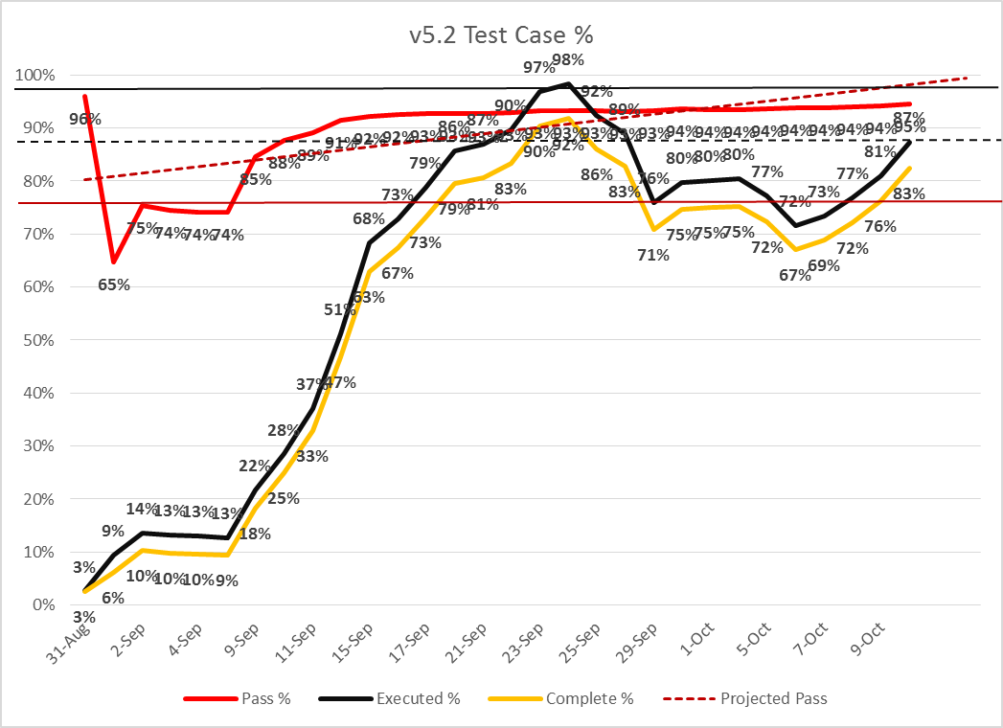

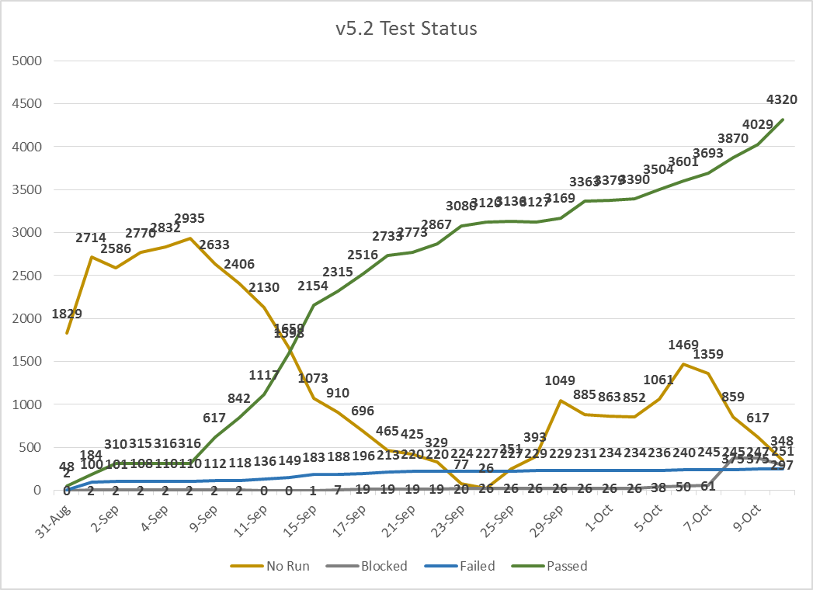
Figure 3 Test Case Growth Charts

Defect Growth
A daily defect growth metric will be collected to show defect find and fix growth. This will help project management to manage risk during the defect fix and testing cycle. This will allow the PM a visual representation of number of defects found and fixed per day and the potential for meeting planned milestones. A template will be used for each project and reported to the PM and SQA manager on a daily basis during formal SQA testing phase. For an example graph, see Figure 4 Defect Growth Chart
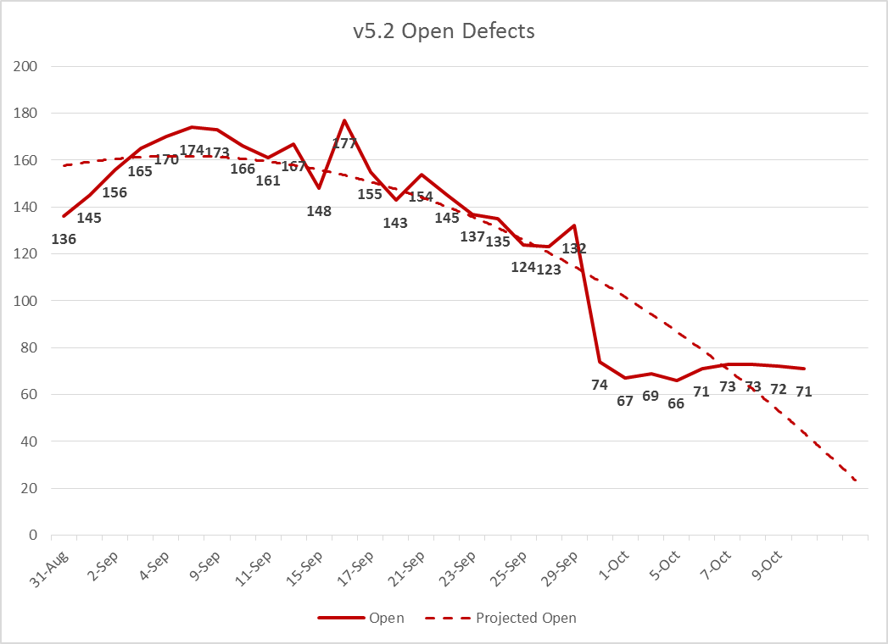
Figure 4 Defect Growth Chart

Entry and Exit Criteria
Entry and exit criteria are to be used as a guideline for each project. The criteria will be outlined in the project test plan.

SQA Test Entry Criteria:
• Application software has been checked into software repository.
• All unit and development tests completed
• The test data has been prepared.
• The software is built and installed software in the SQA environment.
• Test Plan and Test Case reviews have been completed and any recommended corrections made.
• All regression tests (automated and manual) have been identified and ready for use.
• 100% execution of the unit and dev integration test cases.
• Completion of a SQA hand off meeting. This meeting is to discuss what is in the build and any defects that have been discovered and not fixed.

SQA Test Exit Criteria:
  - 95% execution of SQA Test cases (System, Regression, and Performance).
  - 75% Pass rate of all executed SQA test cases.

  - All open issues identified during SQA Test are documented and business impacts identified. Those that were not fixed have been recorded in JIRA with final disposition and communicated to the Product Management team.
  - No unresolved Severity 1 and 2 defects exist.
  - Minimal Severity 3 defects remain unresolved
  - No unresolved Priority rating 1 and 2 defects exist.
  - Test results and metrics have been documented in the Final test report.
  - Project Management approval.

Roles and Responsibilities and Software Tools

SQA Roles and Responsibilities
Documentation Review
- Business Requirements
- Functional Requirements (Use Cases)
- Design Documentation
- System Specifications
- Implementation/ Deployment Plan
Test Artifact Production
- Requirements and Design Gap Analysis (Traceability Matrix)
- Project Plan input (Testing Activities)
- Test Plan
- Test Cases
- Test Scripts
- Test Metrics

Testing
- Test Case Execution
- Defect Tracking and Issue Resolution
- Issue Review Meetings
- Test Data Creation and Maintenance
- Test Environment Management
- Risk Identification and Analysis
- Test Status Reporting
- Performance Test Report
Empowerment
- Enforcement and Advisement of Test Entry and Exit Criteria (Advisement)
- Secured and locked down test environment
- Controlled Builds to SQA

SQA Manager is responsible for all aspects of the quality program for assigned products and projects. In addition, the SQA manager is responsible for SQA strategy and assignment of personnel for new products and projects. The SQA manager interfaces with 3rd party development vendors for software quality requirements and with contractor vendors for resource needs. The SQA manager shall be the subject matter expert for all SQA program matters.

The Project Quality Lead is responsible for planning and overseeing all SQA activities on a project. The PQL will be the subject matter expert on the product for Quality issues. The PQL will also create the Traceability Matrix, Test Plan, and daily Test Metrics. The PQL directs on a daily basis, all assigned resources to insure test activities are executed according to the Test Plan.

The Tester is responsible for all aspects of SQA testing, including system, regression activities, as defined by the Test Plan for the specific project. The Tester creates test data and test scripts to formulate a repeatable Test Suite that can be leveraged for Regression Testing.

Automation Engineer is responsible for creation and execution of automated scripts and reporting results.

Software
The following software will be used for testing the systems, maintaining the test cases, recording, and tracking the defects, generating reports etc.

Software | Description | Team
JIRA | Defect Management | SQA, Software Engineering, Management
UFT, cFactory | Automation - Regression Testing | SQA
ALM/Quality Center | Maintain all test cases; maintain record of testing done during each iteration; maintain traceability through requirement coverage and analysis; record test results; generate test status reports, Maintain requirements (TBD) | SQA, BA(TBD)
Excel | Quality Metrics | SQA
Word | Quality Reports | SQA

Defect Management

Defects identified during the test phase (System, Regression, Integration, and Beta) that are in the scope of the changes made for the applications will be entered into JIRA as a defect issue type and managed using a defect status report. Project management will work with the SQA and Software Engineering teams to track issues to resolution in a timely manner. See Figure 5 Defect Workflow for Defect life cycle
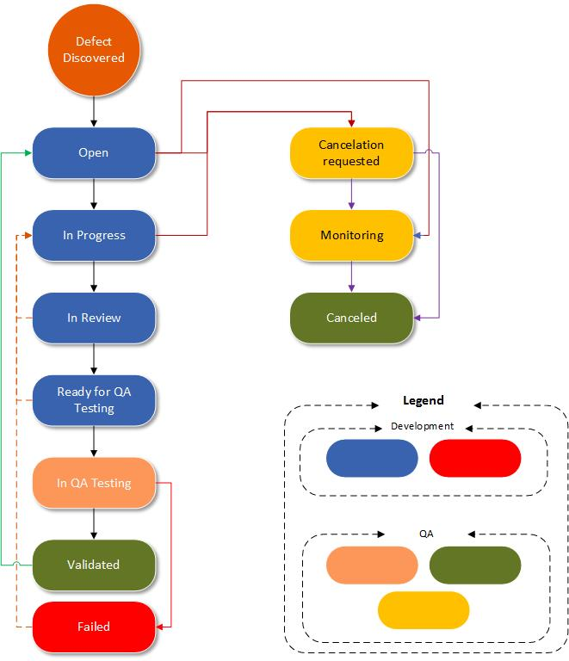
Figure 5 Defect Workflow

Required and Option fields for Defect Tracking
Required Fields | Optional Fields
Reporter | Due Date
Priority | Attachment
Severity | Environment
Component/s
Summary
Affects Version/s
Description
Resolution Information
Cancellation Request Information
Validation Information
Failure Information
Fix Version/s (On Validation Screen)
Root Cause

Project Defect meeting
A project defect meeting will take place on a daily basis at the start of the project-testing phase. This meeting can then progress to a twice a week meeting as the need arises based on a decision of the meeting attendees. In attendance for this meeting will be at a minimum the Project Quality Lead, Software Engineering lead, and the Project Manager. The meeting shall be a forum to discuss the defects that are opened, ready for test, and any questions each team may have on the issues. The PM shall be kept abreast of any “In Disputes” and any possible recommendations as to when or how the issue can be fixed.

Product Defect meeting
A product defect meeting will take place on a monthly basis. In attendance for this meeting will be at a minimum the Line of business representative, SQA manager, Project Quality Leader, and Software Engineering manager, and the Project Manager. The meeting shall be a forum to discuss the defects that are opened, prioritize them and possibly assign them to an upcoming release for correction.

Defect Priority Classifications
Below is the list of priority classifications to be used by the team during the SQA and UAT phase for defects entered into JIRA. This classification categorizes the impact to the business and users. It is used in conjunction with severity
Table 1 Defect Priority Classifications
Priority | Definition
High | - Defect holds up deployment to users.  - Client or Line of Business will not accept defect in release.  - Defect must be fixed before next release to SQA.  - Defect affects all users and has a significant impact on business.
Medium | - Defect holds up final deployment to customer.  - Client or Line of Business will not accept defect in final release.  - Defect must be fixed before final release to SQA.  - Defect effects most users and has a impact on business.
Low | - Defect is allowed to remain in the product.  - Client or Line of Business will accept defect in final release.  - Defect does not affect users and has no impact on business.

Defect Severity Classifications
Below is the list of defect classifications to be used by the team during the SQA and UAT phase. This classification categorizes the severity of the defect, or how it impacts the software operation.

Table 2 Defect Severity Classifications
Severity | Definition
Critical | - Critical Defect causing System Failure  - Product is unusable due to :  - Crashing (terminates in unexpected or abnormal manner)  - Hanging (stops responding to normal user interactions, must kill or restart)  - Data loss (stored data or user input is lost, changed, or added to in a manner not consistent with normal operation)
Major | - Major Defect with no workaround  - Product does not perform as advertised in datasheet, manual, application literature  - Product is usable, but severely restricted.  - User cannot use the product to get their job done without risking the loss of data from the current work session or loss of previously acquired data.  - Product is usable but produces incorrect results.  - Major feature does not work as required.
Minor | - Medium Defect with workaround  - Product is usable, but there are some limitations in the feature set  - Defect impairs the ability for the user to get their job done, then a workaround solution must exist  - The user is annoyed, but the defect does not cause them to stop using the product  - The product does not perform the way it was intended to, but the user can still get the job done
Trivial | - Minor Defect  - Product is functionally correct  - Product is usable with a small amount of inconvenience  - Product performs in an inconsistent manner, or may require some effort by the user to proceed  - Workarounds are obvious and easy to use  - Cosmetic defects, on-line help defects, spelling defects  - User experiences a small amount of frustration because the product contains minor problems, but they are able to ignore them  - Defects are easy to fix and have a low impact on the product without a high priority to be fixed

Test Tool Integration
The SQA team will make use of several tool suites during a project. Tools suites are categorized as: Defect Management, Test Management, Automated Regression, Automated Performance, Requirements Management, and Security.

Defect Management
For defect management the SQA team will draw on JIRA. JIRA is a product of Atlassian. JIRA will allow us to prioritize, assign, track, report and audit defects, no matter when they are discovered. Defects will follow a predefined workflow (see Figure 5 Defect Workflow). In addition, we can use JIRA to track new features during development and testing. This will ensure that new features being added to an application will be tested and all defects found during the testing are traced back to the original feature. This gives the development and SQA teams a historical record of the feature and defects created. JIRA will be connected to ALM/Quality Center via a plug-in provided by (TBD). This will allow defects to be cross linked to test cases.

Test Management
For test management the SQA team will take advantage of ALM/Quality Center. ALM/Quality Center is a product by Hewlett-Packard. ALM/Quality Center will allow SQA to
- Prioritize test cases based on business risk
- Access testing assets anytime, anywhere via a browser interface
- Create an end-to-end quality management infrastructure
- Manage manual and automated tests.
- Accelerate testing cycles by scheduling and running tests automatically, unattended, 24x7
- Manage multiple versions of requirements, test cases, test scripts and business components
- Enforce standard processes and best practices
- Analyze application readiness at any point in the testing process with integrated graphs and reports

Test Case Tracking
All test cases and the executions of the test cases will be created and tracked in ALM/Quality Center. Test cases will reside within the product (Domain) for which it was created to test. Test cases will be linked to the feature or defect for which it was created.

ALM/Quality Center Project
Individual domains will be created by the site administrator for each Company product. A project with the product name will be created within the domain, as shown in the example below with Standard. The site administrator will also assign a project administrator.
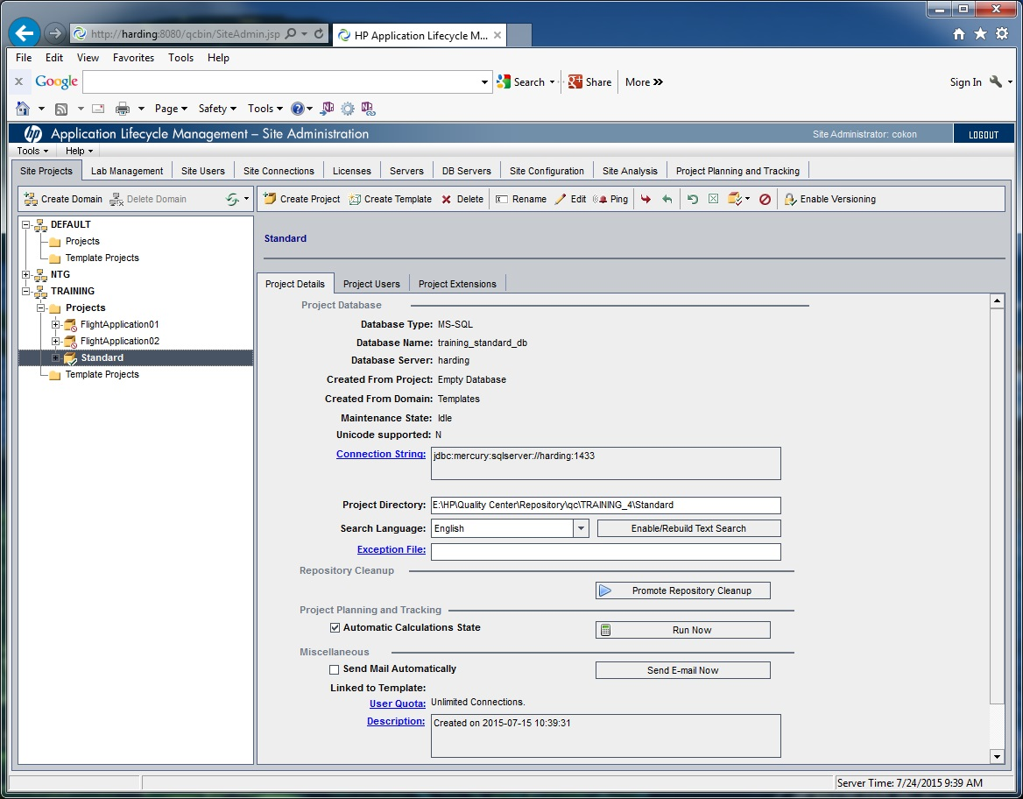
Figure 6 Project Set up

Quality Center Releases and Cycles
A release is an organizational element designed to relate to a product release.
Create a release number and\or name for the project. Enter a description about the release. Specify start and end dates. A Cycle is a build of a release. A cycle will have start and end dates. Create cycle(s) as necessary.

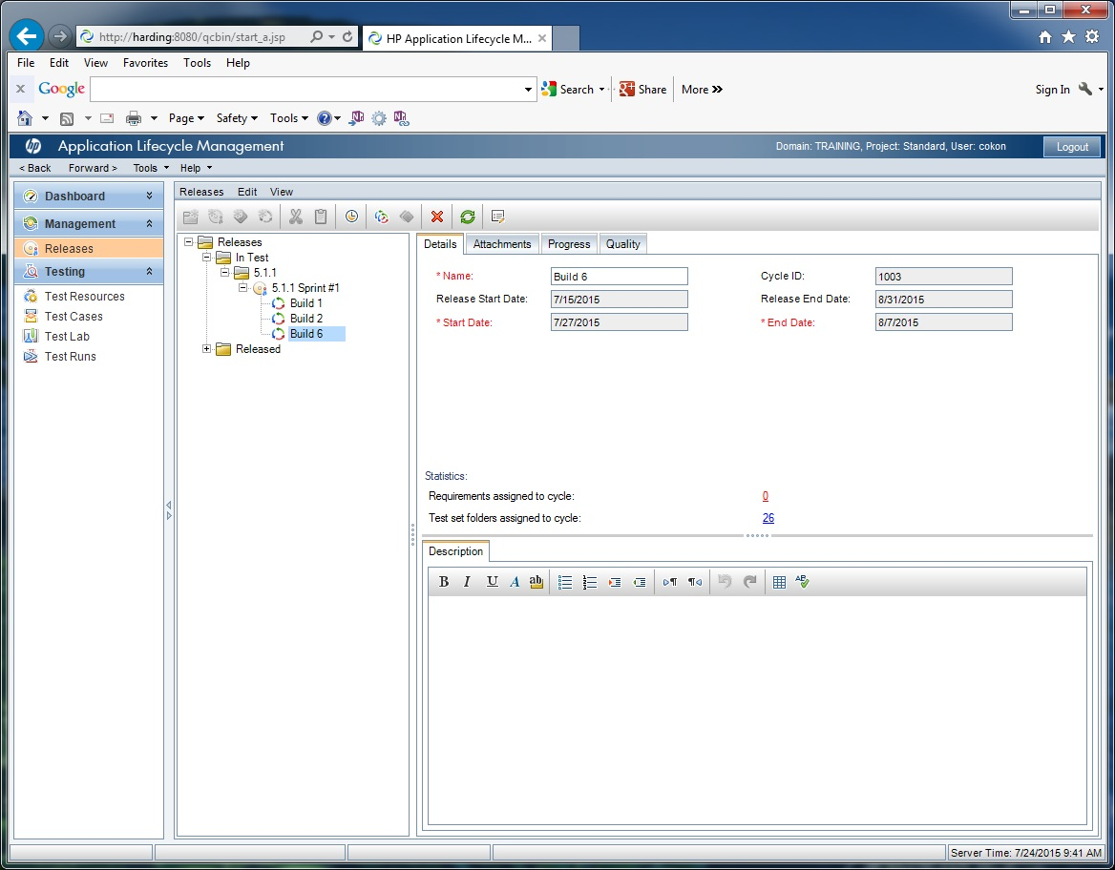
Figure 7 Quality Center Releases

Quality Center Test Plan and Test Lab

Test Cases
Organize test types in a folder structure like below for the project.
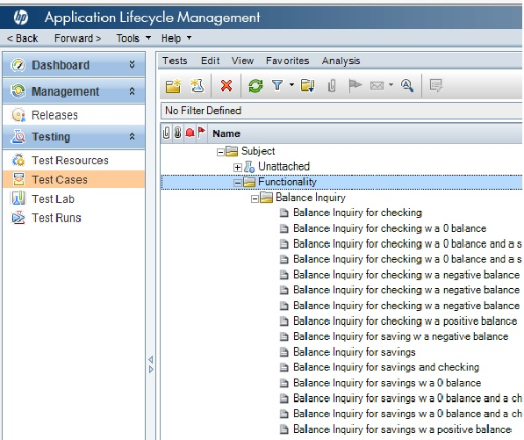
Figure 8 Quality Center Test Plan Hierarchy

Test Cases
Quality Center will have the following data for use in creating a test case:

- Prerequisites- This is field is to outline any prerequisites for running the test cases. (Required field)
- Requirement # – This is used to enter the requirement the test case is testing. This will be used for traceability.
- Test Priority- Single selection box to indicate the priority of the test case. The priorities are outlined in section 4.11.1. (Required field)
- Design Steps – Steps to be run to execute the test case. (For Regression tests)
- Test Name – Name of the test case (Required field)
- Description – A description of the test case. Defines the objective of the test case. (Required field)
- JIRA - corresponding JIRA issue
- Test Type- Functional, Performance, Regression and Smoke, (Multi-Select and Required Field)

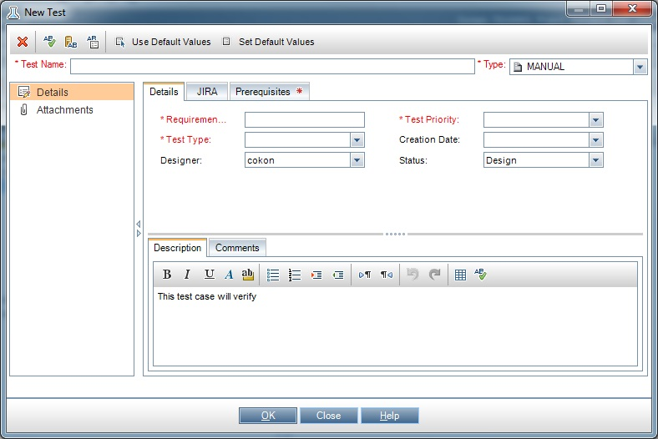
Figure 9 Quality Center Test Case Tabs

Test cases shall have a description of the test and requirement reference.

Test Case Lab Execution Status
- No Run – Test Case has not been executed for the current version under test.
- Not Completed – Test case execution has started but not completed.
- Failed – Test case has failed.
- Passed – Test Case has passed, the expected result is the same as the actual result.
- Blocked – Test Case execution is being blocked by a defect.
- N/A – Will not be used

Automated Regression
Automated Regression applies to UFT by Hewlett-Packard is a script-based test tool widely used for web and windows applications. cFactory by Turnkey is a scripting tool the utilizes UFT and ALM to automatically create scripted test cases.

Automated Performance
TBD

Risks and Issues

Risk Description | Problem | Impact | Mitigation
Establishment of SQA automation methodology | High | High | POC
Requisite skill sets for testing highly technical and sensitive systems. | High | High | Training.
Communication | High | High

References

Industry Standards and Guidances

IEEE Std 829-2008, Standard for Software Test Documentation

